1)The build should trigger as soon as anyone in the dev team checks in code to master branch.

**Create new project: Maersk**

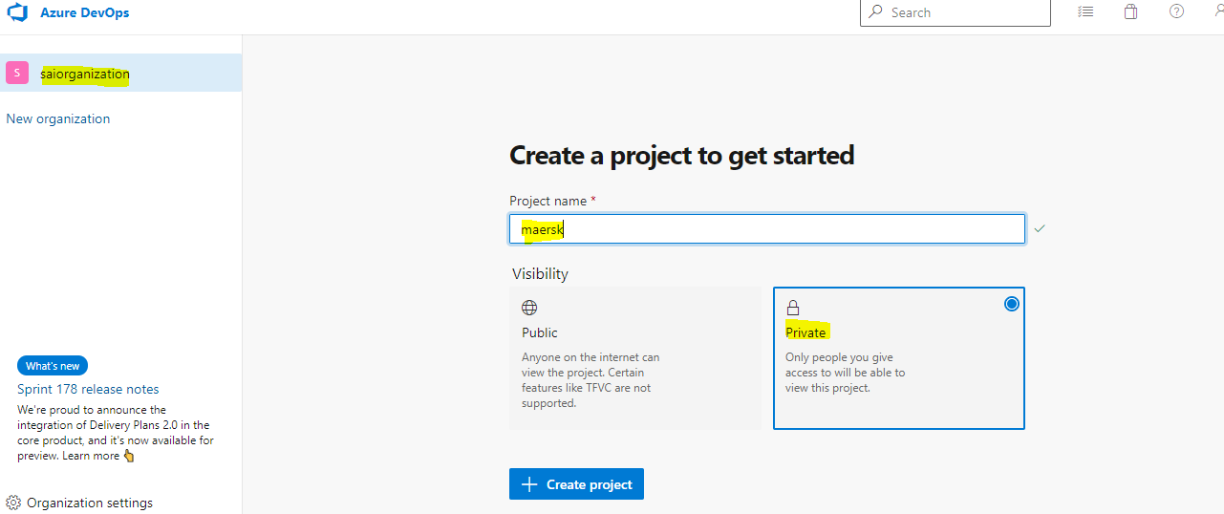

**Create repository: Maersk**

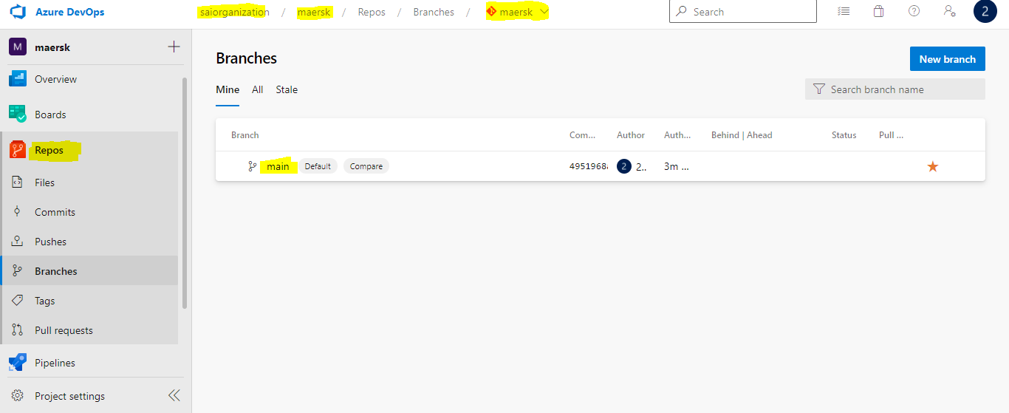

**Note:** Assuming Main branch is Master Branch (Technically we don’t take like this, As per your scenario we are obeying this condition).

**Create New Build Pipeline: Maersk-Car-Rental-Ci-WebApp**

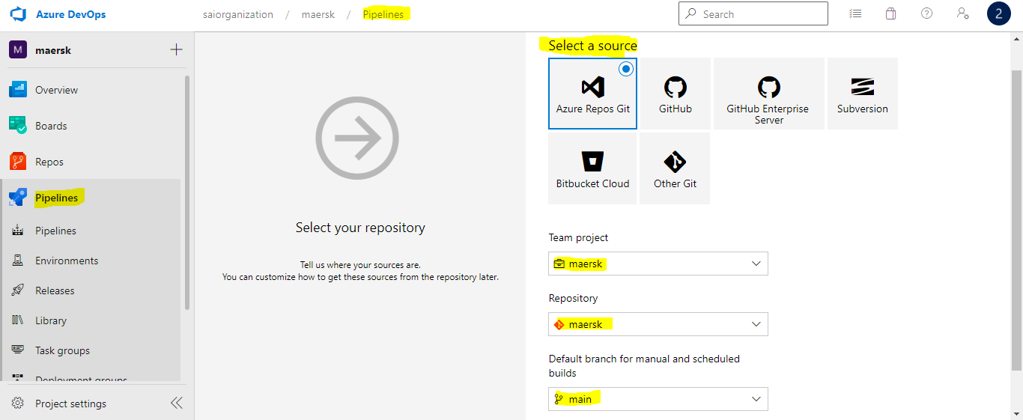

Selecting the Maersk Repo as Source and Main branch as master from azure Repository.

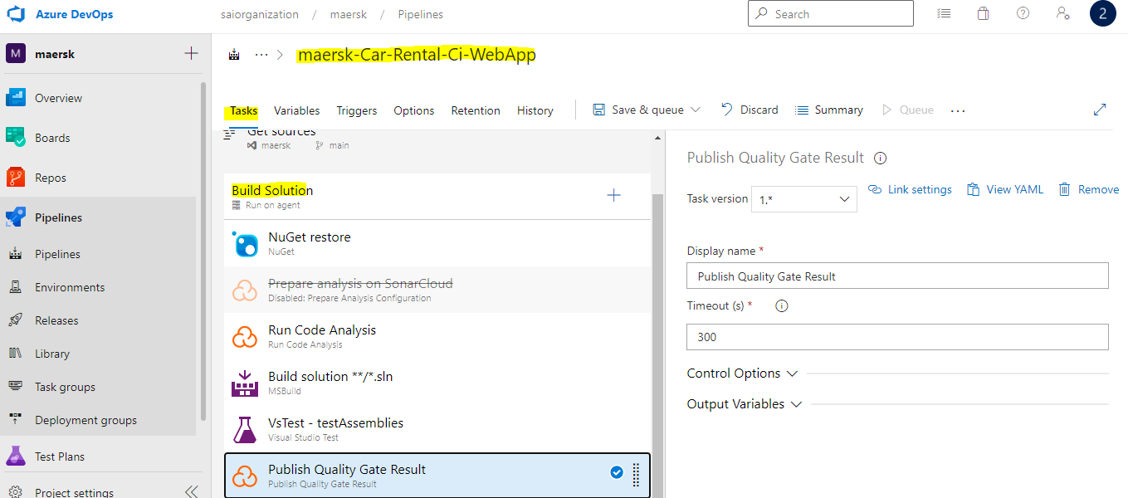

**Created build pipeline with set of agent tasks for the .Net application**

**Create Continuous Integration Trigger on Master Branch:**

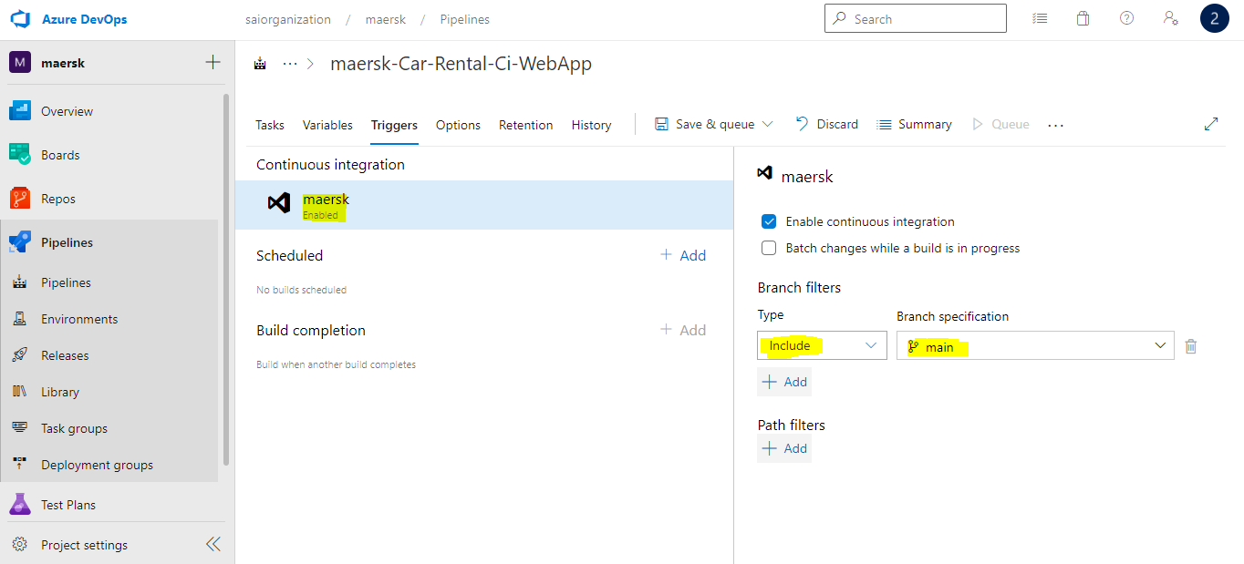

2) There will be test projects which will create and maintained in the solution along the Web and API. The trigger should build all the 3 projects - Web, API and test.

The build should not be successful if any test fails.

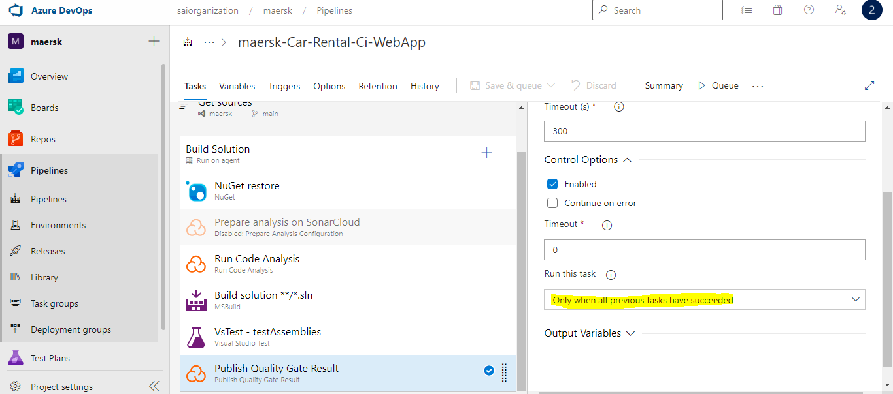

Fail the job when the unit testcase fails

We can create multiple projects and pipelines as above for web app and api

1. **The deployment of code and artifacts should be automated to Dev environment.**

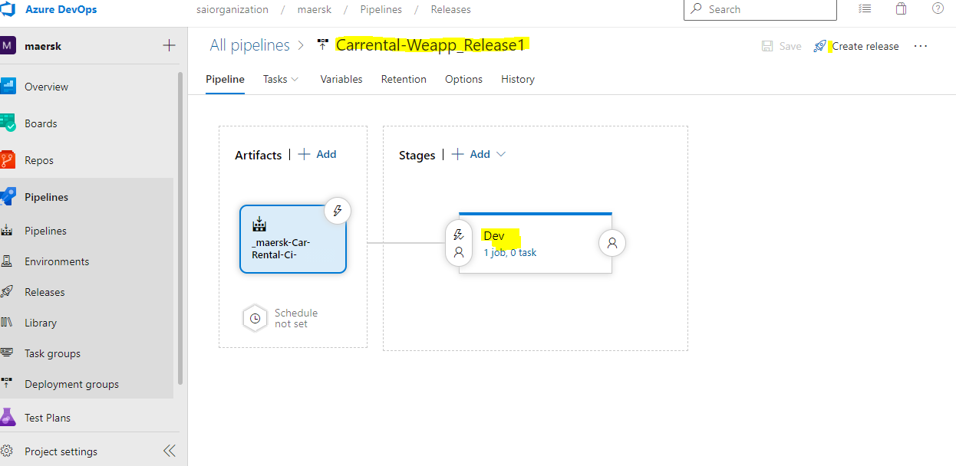

Created Dev Env

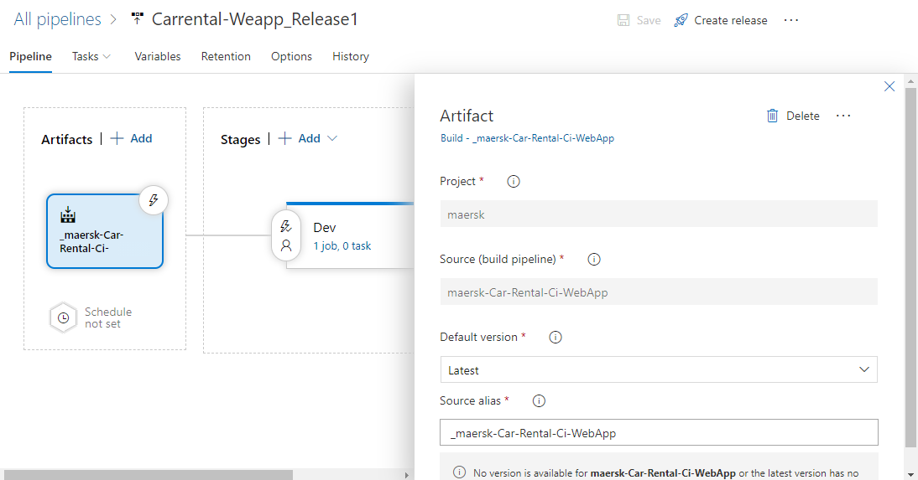

Continues Deploy to the Dev env after every successful build

1. Upon successful deployment to the Dev environment, deployment should be easily promoted to QA and Prod through automated process.

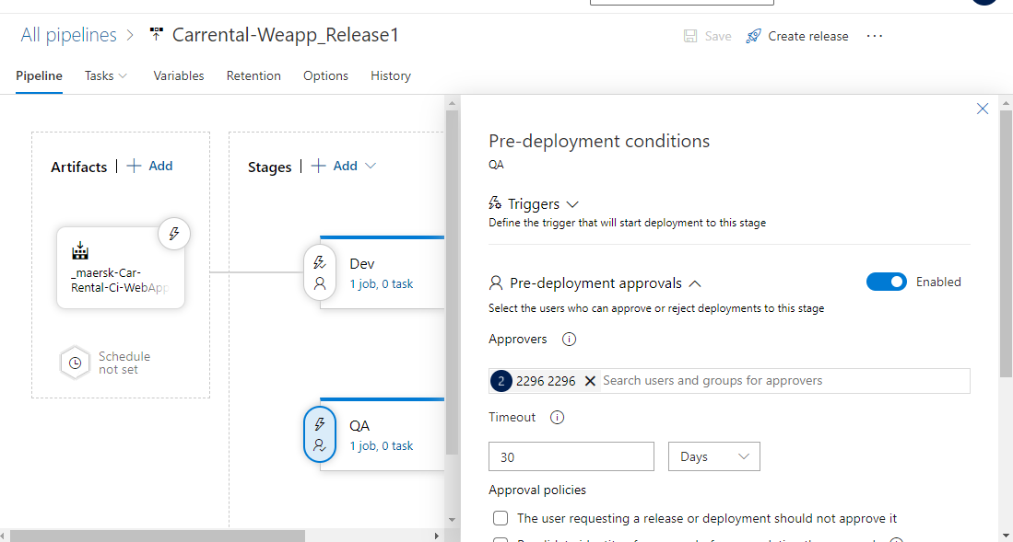

Approvals to QA and we can add prod